**1000**

**500**

**0**

# Crime Analysis Report Total Crimes

**Crime By Years**

**▼ -171**

**▲ 667**

875

1046

379

**-**

**2021 2022 2023**

**Jan Feb Mar Apr May Jun Jul Aug Sep Oct Nov Dec**

**Dangerous** Crime Time is

# Crime By Month/Weekday

**.**



The resolved Crime rate accounts **70.17%**

Power BI Desktop

The unresolved crime rate accounts **29.83%**.

# Type of Crimes

 Anti-Social Behaviour

 Bicycle Theft

 Burglary

 Criminal Damage and Arson

 Drugs and Illegal Substances

 Possession of Weapons

 Public Order

 Robbery and Mugging

# Crime By Time-range

**00:00 - 2:59**

**21:00 - 23:59**

**18:00 - 20:59**

**330**

**405**

**Sat**

**Fri**

**Thu**

**Wed**

**Tue**

**Mon**

**Sun**

**595**

# Crime Monthly Trend

 Shoplifting

# Crime By Province

**3:00 - 5:59**

**15:00 - 17:59**

**6:00 - 8:59**

**12:00 - 14:59**

**9:00 - 11:59**

**244**

**201**

**194**

**179**

**152**

**200**

## **0** - ▼ -12.1% ▲ 28.1% ▼ -11.2% ▲ 10.9% ▼ -10.4% ▲ 11.0% ▼ -9.9% ▲ 29.5% ▲ 27.2% ▼ -33.7%▼ -7.9%

**Jan Feb Mar Apr May Jun Jul Aug Sep Oct Nov Dec**

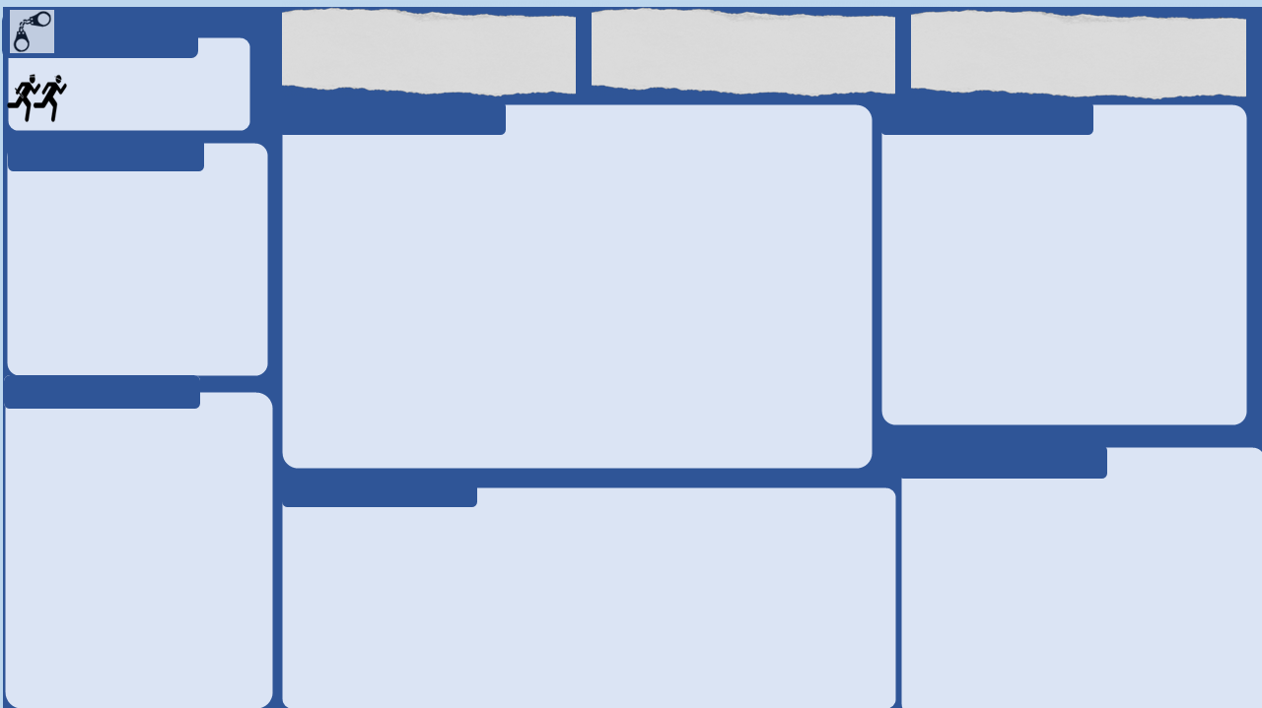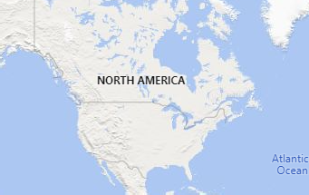

**Build a visual**  

Visual types

Off Suggest a type Data

**+Add data**



© 2023 TomTom,, © 2024 Miiccrrossofftt Corrporrattiion

# Crime Analysis Report

Power BI Desktop

# Type Of Crimes

# Total Crimes

Violence and Sexual Offences

Anti-Social Behaviour

Criminal Damage and Arson

Public Order

Vehicle Crime

Shoplifting Burglary Drugs and

Illegal Substances

Bicycle Theft

Possession of Weapons

Theft from a Person

Robbery and Mugging

⨯ **Dangerous** Crime Time is

✔ **Low** Crime Time is

23:05:00

22:05:00

# Time v/s Total Crime

**Build a visual**  

Visual types

Off Suggest a type Data

**+Add data**



30

20

10

22:00 22:15 22:30 22:45 23:00 23:15 23:30 23:45

# Drill-Through Details

The entire chart on this page is associated with 21:00 - 23:59